European Cybersecurity Month 2019 is launched

October marks the kick-off of the European Cybersecurity Month (ECSM), coordinated by the European Union Agency for Cybersecurity (ENISA), the European Commission and supported by the Member States. This campaign will focus on expanding awareness about cybersecurity to citizens across Europe.

Published on September 30, 2019

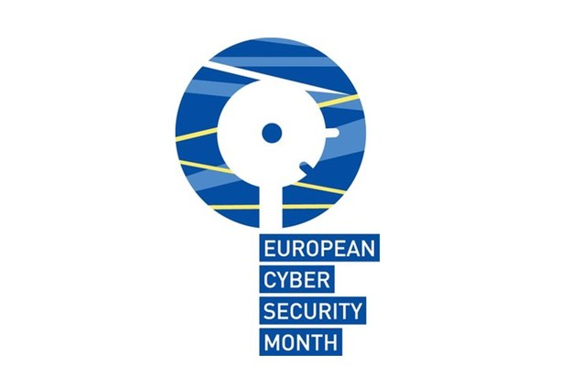

Tagged with

* [cybersecurity](https://www.enisa.europa.eu/search?Subject%3Alist=cybersecurity)
* [ENISA events](https://www.enisa.europa.eu/search?Subject%3Alist=ENISA%20events)

[https://www.enisa.europa.eu/news/++resource++country-flags/bg.gif](https://www.enisa.europa.eu/news/ecsm-2019-pr/cnect-2019-00640-00-00-bg-tra-00.pdf) [https://www.enisa.europa.eu/news/++resource++country-flags/cz.gif](https://www.enisa.europa.eu/news/ecsm-2019-pr/cnect-2019-00640-00-00-cs-tra-00.pdf) [https://www.enisa.europa.eu/news/++resource++country-flags/dk.gif](https://www.enisa.europa.eu/news/ecsm-2019-pr/cnect-2019-00640-00-00-da-tra-00.pdf) [https://www.enisa.europa.eu/news/++resource++country-flags/de.gif](https://www.enisa.europa.eu/news/ecsm-2019-pr/cnect-2019-00640-00-00-de-tra-00.pdf) [https://www.enisa.europa.eu/news/++resource++country-flags/es.gif](https://www.enisa.europa.eu/news/ecsm-2019-pr/cnect-2019-00640-00-00-es-tra-00.pdf) [https://www.enisa.europa.eu/news/++resource++country-flags/ee.gif](https://www.enisa.europa.eu/news/ecsm-2019-pr/cnect-2019-00640-00-00-et-tra-00.pdf) [https://www.enisa.europa.eu/news/++resource++country-flags/fi.gif](https://www.enisa.europa.eu/news/ecsm-2019-pr/cnect-2019-00640-00-00-fi-tra-00.pdf) [https://www.enisa.europa.eu/news/++resource++country-flags/fr.gif](https://www.enisa.europa.eu/news/ecsm-2019-pr/cnect-2019-00640-00-00-fr-tra-00.pdf) [https://www.enisa.europa.eu/news/++resource++country-flags/gr.gif](https://www.enisa.europa.eu/news/ecsm-2019-pr/cnect-2019-00640-00-00-el-tra-00.pdf) [https://www.enisa.europa.eu/news/++resource++country-flags/hr.gif](https://www.enisa.europa.eu/news/ecsm-2019-pr/cnect-2019-00640-00-00-hr-tra-00.pdf) [https://www.enisa.europa.eu/news/++resource++country-flags/hu.gif](https://www.enisa.europa.eu/news/ecsm-2019-pr/cnect-2019-00640-00-00-hu-tra-00.pdf) [https://www.enisa.europa.eu/news/++resource++country-flags/it.gif](https://www.enisa.europa.eu/news/ecsm-2019-pr/cnect-2019-00640-00-00-it-tra-00.pdf) [https://www.enisa.europa.eu/news/++resource++country-flags/lt.gif](https://www.enisa.europa.eu/news/ecsm-2019-pr/cnect-2019-00640-00-00-lv-tra-00.pdf) [https://www.enisa.europa.eu/news/++resource++country-flags/lv.gif](https://www.enisa.europa.eu/news/ecsm-2019-pr/cnect-2019-00640-00-00-lt-tra-00.pdf) [https://www.enisa.europa.eu/news/++resource++country-flags/mt.gif](https://www.enisa.europa.eu/news/ecsm-2019-pr/cnect-2019-00640-00-00-mt-tra-00.pdf) [https://www.enisa.europa.eu/news/++resource++country-flags/nl.gif](https://www.enisa.europa.eu/news/ecsm-2019-pr/cnect-2019-00640-00-00-nl-tra-00.pdf) [https://www.enisa.europa.eu/news/++resource++country-flags/pl.gif](https://www.enisa.europa.eu/news/ecsm-2019-pr/cnect-2019-00640-00-00-pl-tra-00.pdf) [https://www.enisa.europa.eu/news/++resource++country-flags/pt.gif](https://www.enisa.europa.eu/news/ecsm-2019-pr/cnect-2019-00640-00-00-pt-tra-00.pdf) [https://www.enisa.europa.eu/news/++resource++country-flags/ro.gif](https://www.enisa.europa.eu/news/ecsm-2019-pr/cnect-2019-00640-00-00-ro-tra-00.pdf) [https://www.enisa.europa.eu/news/++resource++country-flags/sk.gif](https://www.enisa.europa.eu/news/ecsm-2019-pr/cnect-2019-00640-00-00-sk-tra-00.pdf) [https://www.enisa.europa.eu/news/++resource++country-flags/si.gif](https://www.enisa.europa.eu/news/ecsm-2019-pr/cnect-2019-00640-00-00-sl-tra-00.pdf) [https://www.enisa.europa.eu/news/++resource++country-flags/sv.gif](https://www.enisa.europa.eu/news/ecsm-2019-pr/cnect-2019-00640-00-00-sv-tra-00.pdf)

The 2019 campaign focuses on different themes addressing the need for behavioural change and identifying opportunities to help users recognise the risks of new technologies.

The first theme encompasses basic ‘Cyber Hygiene’, which uses the hygiene metaphor to inform about good cybersecurity habits that are part of everyone’s daily routine. Having healthy cyber safety practices can provide users with more confidence using their devices, whether it’s a computer, a smart phone, a wearable device or any other gadget that’s connected to the internet. The key take-home message conveys that cyber hygiene is a habit you learn from a young age and remains a daily routine for life.

The second theme concentrates on ‘Emerging Technology’ and recognises the importance of keeping you and your new tech gadgets and devices secure. Technology is developing fast and it is important to question the security and privacy settings for your new purchases. For this theme, citizens will be guided around the topics they should be aware of when it comes to new technology.

European Commissioner for Digital Economy and Society **Mariya Gabriel** said: "Today we launch European Cybersecurity Month 2019, we are boosting awareness around online safety and the cybersecurity skills needed for the future. If we want to complete the Digital Single Market, it is essential we ensure EU citizens, particularly young people have the knowledge and skills to protect themselves online. It is our shared responsibility for all citizens to become responsible users of emerging technologies."

 ENISA’s Executive Director **Udo Helmbrech**t said: “Cyber threats are evolving at a rapid pace and human behaviour can play a fundamental role in how we stay cyber secure. Ensuring that all citizens are aware of online risks and have the tools to become more resilient and confident users is a key goal of European Cybersecurity Month. This October, we urge everyone to stay alert with new technology and establish strong cyber hygiene habits.”

Today to launch the campaign, ENISA has published a [**video**](https://youtu.be/7FK-GebnLkw) that will provide citizens with simple awareness checks to undertake in their daily lives. Furthermore ENISA is organising an ‘Ask Me Anything’ session on Twitter on 30th September at 10:00 CET, for citizens and organisations to pose general cybersecurity questions on how to secure their devices to the EU Agency for Cybersecurity (ENISA).